PR REVIEW
SCC-4486 | Skip Book Appointment & Drop Tasks
Great Plains | OmniStudio orchestration peer review
Review type | PR / peer review only - no IT or UAT execution
Scope | 5 OrchestrationItemDefinition DataPacks | 9 named files
Source evidence | GreatPlainsMerge read-only SOQL | Vlocity CMT 900.650.3.1
Decision | Changes Requested - PR diff and condition evidence required
Boundary | No PR approval/comment, deployment, activation, record write, or org metadata change

PR DECISION
Changes Requested. The nine PR files and diff are unavailable, and the story does not define the authoritative MDU Tenant discriminator. Do not approve until the additive condition logic and dependency preservation are visible in the PR.

Acceptance and PR outcome
# | Review scope | Result | Evidence
1 | Five named items | Partial | All five exist as ManualTask definitions in the Internet Plan; the PR payload itself was not available.
2 | MDU Tenant signal | Fail | Order has nullable MDU identifier fields, but the story and available evidence do not identify which field/value proves tenant status.
3 | Automatic Skipped state | Design fit | Salesforce skips an item when its execution condition evaluates false; the PR must therefore exclude MDU Tenants, not positively select them.
4 | Existing behavior | Unverified | Current conditions contain appointment, fiber method, facility type, and product gates. The PR must add to them rather than replace them.
5 | Downstream continuation | Unverified | Skip Branch is currently false, but ParentKeys and dependency payload changes cannot be reviewed without the PR files.

Condition and dependency design
The safe implementation preserves every existing execution condition and adds one explicit non-MDU gate. A false result for an MDU Tenant produces the required Skipped state while downstream work continues only if Skip Branch remains false.
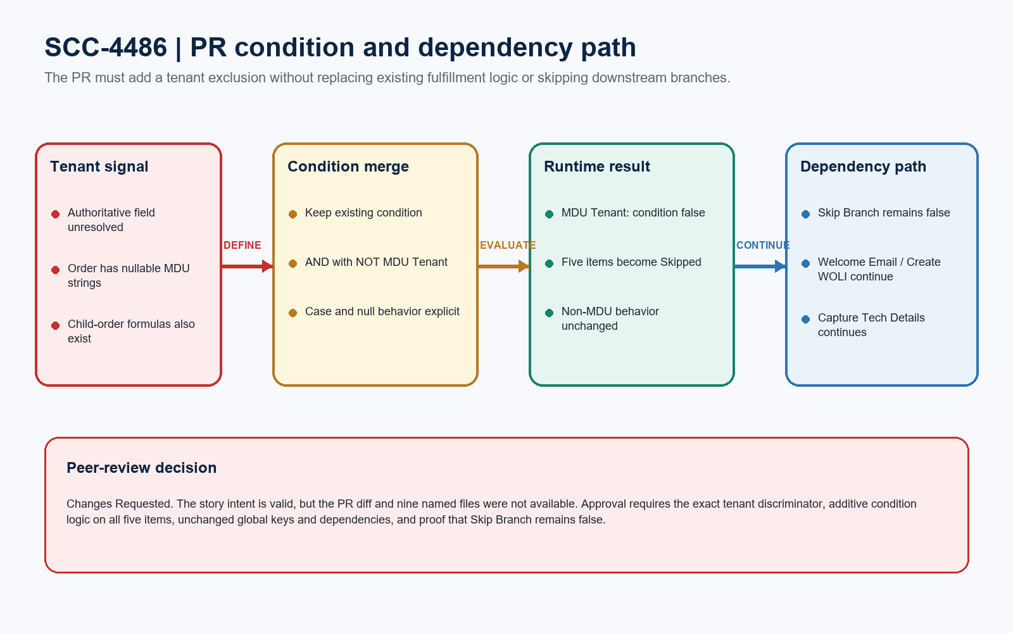
Figure 1. SCC-4486 PR condition and dependency path
LOGIC REQUIREMENT
Required pattern: ExistingCondition AND NOT(IsMDUTenant). Do not replace the existing condition, invert the result, or enable Skip Branch.

PR findings and required modifications
Severity | Finding | Required PR change / evidence
High | PR diff unavailable | Provide the PR URL/diff and all five DataPack.json plus four ParentKeys.json files. Approval cannot be evidence-based without them.
High | Tenant discriminator unresolved | Name the authoritative field, order context, exact value/null rule, and case handling. The available Order MDU fields are nullable strings, not an explicit Tenant flag.
High | Condition direction | The tenant clause must make the whole execution condition false for MDU Tenant orders. A positive MDU match would execute the task instead of skipping it.
High | Existing-condition preservation | Nest the current task condition with the tenant exclusion. Do not remove appointment status, installation method, facility type, or product-code logic.
Medium | Parent/child order context | Confirm whether orchestration reads Order.MDU_Identifier_* or the parent-order formula fields; use the field populated in the runtime order context.
Medium | Multi-item semantics | Confirm mixed-order behavior because an orchestration condition can be met when any associated order item meets it.
Medium | Case, null, and missing data | Define behavior for blank MDU identifiers and exact case-sensitive values so ordinary orders are not skipped accidentally.
Medium | Dependency blast radius | Keep IsSkipBranch false and preserve global keys. Book Appointment gates Triage, Welcome Email, and Create WOLI; Splice gates Capture Tech Details.
Medium | Product path inconsistency | Install Drop currently uses Product2.ProductCode while the other drop items use vlocity_cmt__Product2Id__r.ProductCode. Do not normalize this accidentally; confirm the correct runtime node.

REVIEW BLOCKER
The live source snapshot supports design review only. It is not a substitute for the PR diff and must not be used to approve the changed JSON payload.

Five-file condition scope
DataPack | Current source condition | Required PR treatment
Book Appointment | Order.Service_Appointment_Status__c != Scheduled | Add non-MDU gate; retain appointment status logic; keep Skip Branch false.
Triage, Prep-Work & Sitewalk | Installation method + facility type + product | Add the same tenant exclusion without changing dependency or product path.
Notify 811 | Installation method + facility type + product | Add the same tenant exclusion; preserve dependency from Triage and to Install Drop.
Install Drop | Installation method + facility type + Product2.ProductCode | Add the same tenant exclusion; confirm Product2 path before any cleanup.
Splice and Cutover Drop | Installation method + facility type + product | Add the same tenant exclusion; preserve dependency from Install Drop and to Capture Tech Details.

DataPack and ParentKeys controls
Control | Peer-review expectation
DataPack identity | Preserve all five GlobalKey values, plan reference to Internet Plan, ManualTask record type, names, scope, and implementation references.
ConditionData | Change only the intended boolean tree; use valid nested AND/OR/NOT structure and preserve datatype, field-node, operator, and value tokens.
ParentKeys | Review all four modified ParentKeys files for stable existing keys only. Explain why Book Appointment has no ParentKeys file in the stated scope.
Unrelated drift | Reject regenerated IDs, reordered unrelated JSON, environment-specific record IDs, activation changes, or modifications outside the nine named files.
PR evidence | Include a readable before/after condition for each item and a file list proving the PR is limited to SCC-4486.

PR-ONLY BOUNDARY
No IT test, UAT execution, deployment validation, or runtime order result is claimed in this review. Those are separate release gates after the PR is technically approvable.

PR approval gates
# | Required action | Owner | PR evidence needed
1 | Attach exact PR evidence | Developer | PR URL, base/head refs, commit SHA, nine changed files, and per-file patch.
2 | Resolve MDU Tenant identity | Developer / Product Owner | Authoritative field and runtime order context; exact value, case, null, and mixed-order behavior.
3 | Prove additive logic | Developer | Before/after ConditionData for all five items showing ExistingCondition AND NOT(IsMDUTenant).
4 | Prove dependency preservation | Developer / Reviewer | Unchanged GlobalKeys, IsSkipBranch=false, stable ParentKeys, and no downstream branch removal.
5 | Remove unrelated drift | Developer | PR contains only SCC-4486 DataPack/ParentKeys changes and no regenerated IDs or environment-specific values.
6 | Re-review | Peer Reviewer | All high findings resolved in the actual patch; then approve PR or request remaining changes.

Ready-to-paste PR review response
PR COMMENT
PR review completed for SCC-4486. Changes Requested. The story targets five Internet Plan manual tasks: Book Appointment; Triage, Prep-Work & Sitewalk; Notify 811; Install Drop; and Splice and Cutover Drop. The PR URL/diff and nine named files were not available, so the changed ConditionData and ParentKeys cannot be approved. Before re-review, identify the authoritative MDU Tenant field and runtime order context, add the tenant exclusion as ExistingCondition AND NOT(IsMDUTenant) on all five items, preserve each existing appointment/drop condition, keep IsSkipBranch=false, retain all GlobalKeys and dependency keys, and remove unrelated or environment-specific JSON drift. Also confirm blank, case-sensitive, parent/child-order, mixed-order-item, and Product2 path behavior. This is PR review only: no IT test, UAT execution, deployment, activation, record write, or org metadata change was performed.

